P4D PCA Self-Assessment

Q1.1 How is learning valued and encouraged in your partnership with the counterpart institution?

Q1.2 Can you give an example of a time that demonstrates this?

T1. What would improve the culture of learning?
☐ N/A
Filling in triangles: please place the dot to indicate one, two or three points. So:
- If placed in the middle, this means all 3 apply.
- If placed closer to one point, it means this point applies more than the others (but the other two still apply)
- if placed on the edge between two points, it means only these two apply.
- If placed only on one point, this means only this point applies.
- In this example below, it means that the main reasons are availability and value, but that better understanding is also a reason.
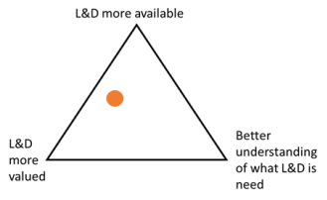
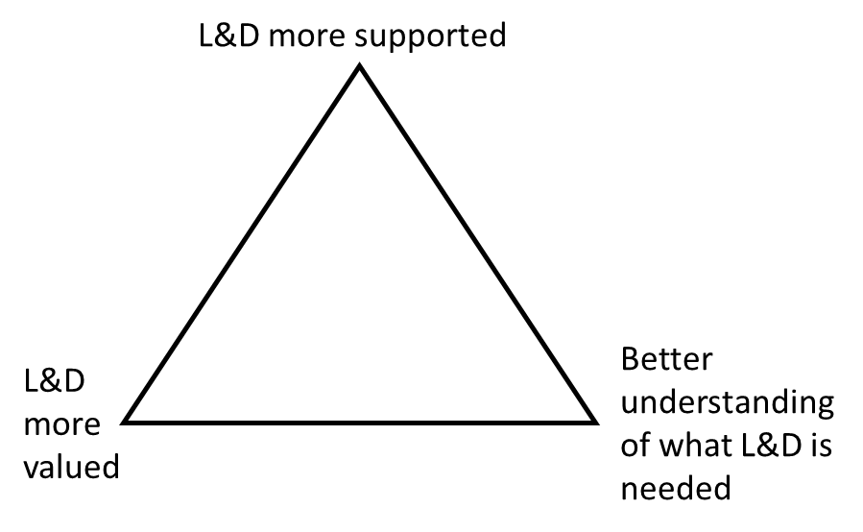
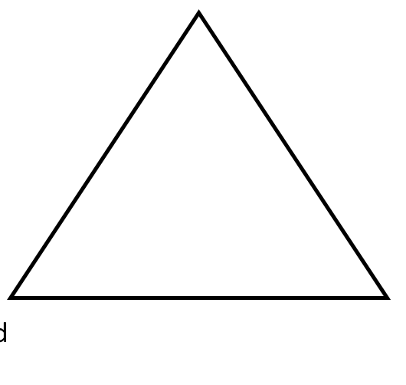

Q2.1 How would you describe your use, or adaptation, of learning from your partnership?

Q2.2 Can you give an example of a time that demonstrates this?

T1. What would improve the use of learning?
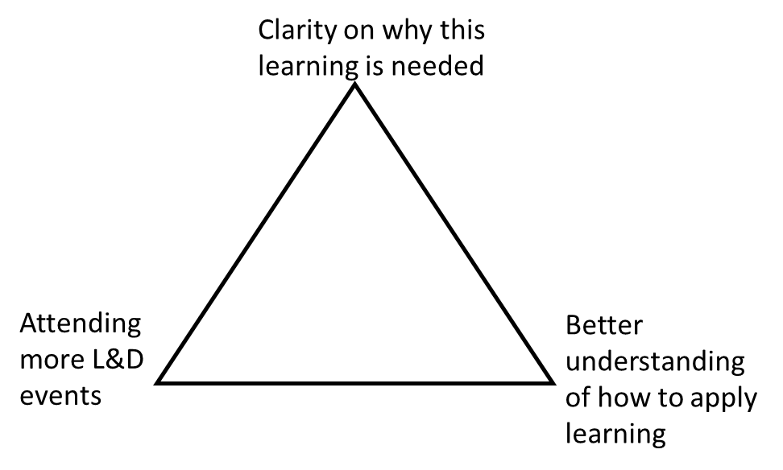
☐ N/A
Q3.1 Can you describe how clear and secure you feel in the goal of your partnership with the counterpart institution? Does the partnership feel strategically aware?

Q3.2 Can you give an example of a time that demonstrates this?

T1. What would improve the strategic direction and clarity of strategy in your partnership?
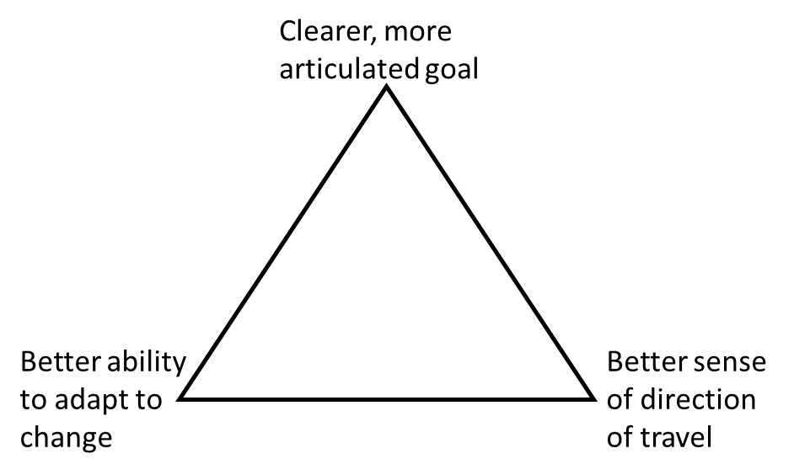
☐ N/A
Q4.1 To what extent does your partnership with the counterpart institution have a structured approach and processes in place? Are these abided by?

Q4.2 Can you give an example of a time that demonstrates this?

T1. What would improve the use of/interaction with processes and a structured approach?
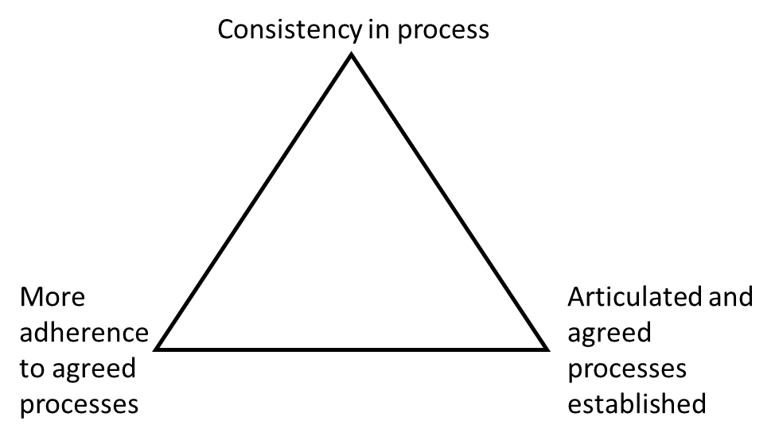
☐ N/A
Q5.1 How would you describe the level of trust in your partnership with the counterpart institution?

Q5.2 Can you give an example of a time that demonstrates this?

T1. What would improve the level of trust with the counterpart institution?
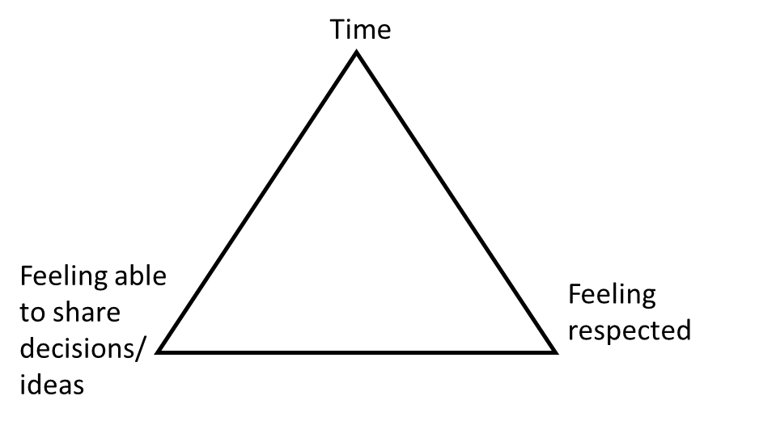
Q6.1 How would you describe the ability to resolve differences and make decisions in your partnership with the counterpart institution?

Q6.2 Can you give an example of a time that demonstrates this?

T1. What would improve decision-making and resolving differences in your partnership?
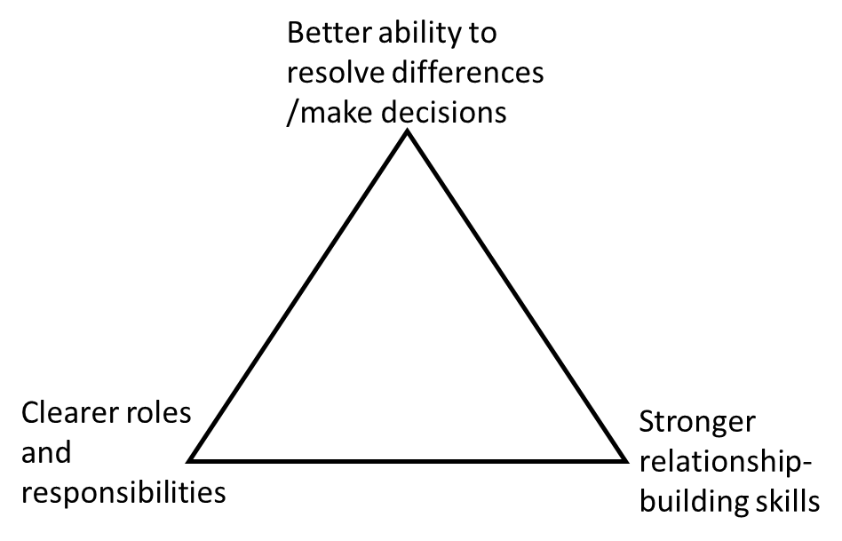
☐ N/A
Q7.1 How would you describe the level of demand for the UK institution’s support? Do you feel the UK institution is able to meet this demand?

Q7.2 Can you give an example of a time that demonstrates this?

T1. What would improve the ability to scale-up the UK institution’s support?
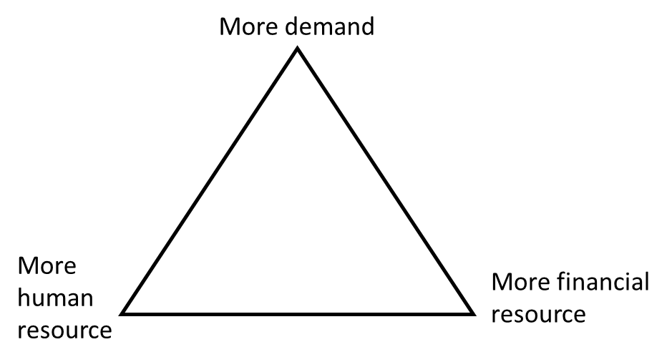
☐ N/A
Q8.1 How would you describe the impactfulness/effectiveness of your partnership?

Q8.2 Can you give an example of a time that demonstrates this?

Q8.3 What would improve the effectiveness?

Q9.1 How would you describe monitoring, evaluation, and learning (MEL) abilities of your partnership with the counterpart institution?

Q9.2 Can you give an example of a time that demonstrates this?

T1. What would improve the MEL abilities?
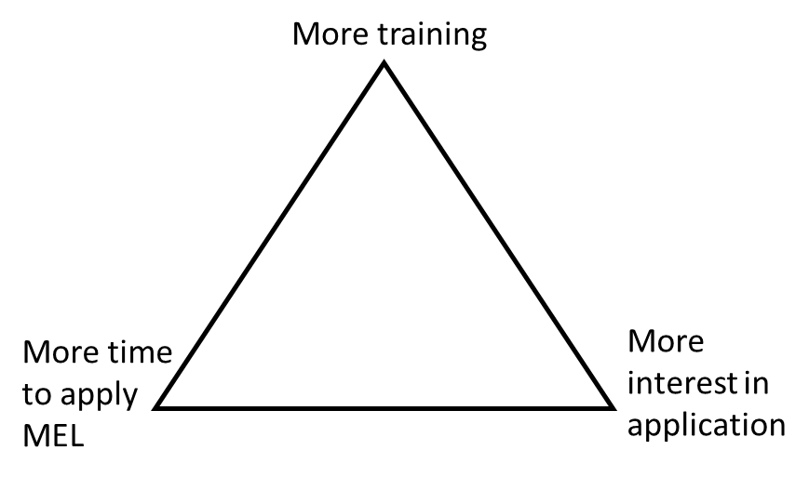
☐ N/A

